**Oom Yung Doe**

**The Grandmaster**

**“Iron” Kim Style**

**8 Martial Arts Taught as 1**

**SELF-DEFENSE WORKSHOP**

# ADT_Logo_NoTag_PPT

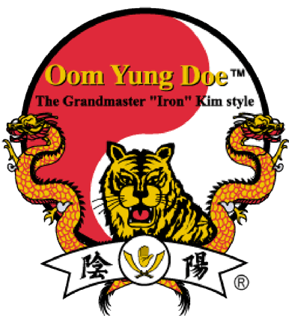

**www.8taughtas1.com**

**Presented by School of Oom Yung Doe in partnership with ADT Security Services**

**Contact us to register:** [**Wallingford@8taughtas1.com**](mailto:Wallingford@8taughtas1.com)**,** [**Crownhill@8taughtas1.com**](mailto:Crownhill@8taughtas1.com) **or** [**Lakecity@8taughtas1.com**](mailto:Lakecity@8taughtas1.com)

**Free for the Community!**

**Event Dates: 2/20, 3/20, 4/17, 5/15, 6/19, 7/17**

<http://seattletimes.com/html/localnews/2020343618_seattleattacksxml.html>

<http://blogs.seattletimes.com/today/2013/02/third-woman-reports-attack-in-north-seattle-all-since-sunday/>

Due to these recent attacks on women, we as a community have chosen to respond, **Oom Yung Doe** in partnership with **ADT Security Services** are offering these workshops to help protect ourselves and the ones we love. We encourage all that can attend to attend!

This series of free Self-Defense Workshops at Seattle area schools of Oom Yung Doe teaches simple, effective techniques for self-defense. These techniques will work in a variety of situations and are immediately effective, even for beginners.

**Bring a friend to make sure you have a practice partner!**

**Every 3rd Wednesday: 6:30pm**

**Three locations:**

Oom Yung Doe Wallingford

3845 Bridge Way N

Seattle WA 98103

[Wallingford@8taughtas1.com](mailto:Wallingford@8taughtas1.com)

206.285.9789

Oom Yung Doe Crown Hill

8543 15th Ave NW

Seattle WA 98117

[Crownhill@8taughtas1.com](mailto:Crownhill@8taughtas1.com)

206.462.1339

Oom Yung Doe Lake City

11530 Lake City Way NE

Seattle WA 98125

[Lakecity@8taughtas1.com](mailto:Lakecity@8taughtas1.com)

206-427-9798

